#include<windows.h>
#include<GL/glut.h>
#include<iostream>
#include<cmath>
using namespace std;

float x1,x2,x3;
float Y_1,y2,y3;
float tx,ty;
float sx,sy;
float angle;
float shx,shy;
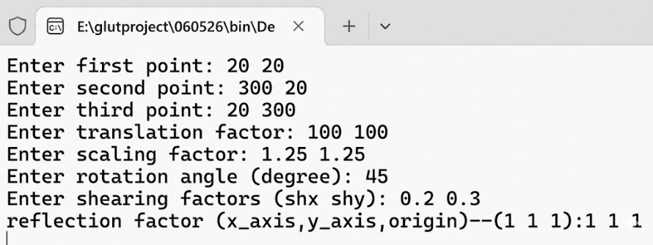
int x_axis,y_axis,origin;
void or_triangle(){
glColor3f(0.0, 0.0, 0.0);
glBegin(GL_LINES);
glVertex2i(x1,Y_1);
glVertex2i(x2,y2);
glVertex2i(x2,y2);
glVertex2i(x3,y3);
glVertex2i(x3,y3);
glVertex2i(x1,Y_1);
glEnd();
}
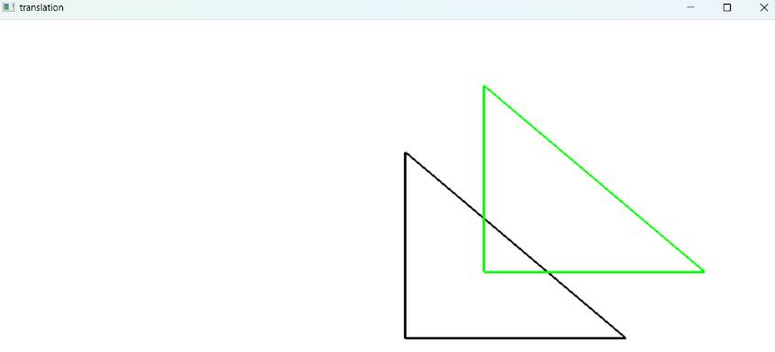
void translation(){
glClear(GL_COLOR_BUFFER_BIT);
glLineWidth(3);
or_triangle();
glColor3f(0.0, 1.0, 0.0);
glBegin(GL_LINES);
glVertex2i(x1+tx,Y_1+ty);
glVertex2i(x2+tx,y2+ty);
glVertex2i(x2+tx,y2+ty);
glVertex2i(x3+tx,y3+ty);
glVertex2i(x3+tx,y3+ty);
glVertex2i(x1+tx,Y_1+ty);
glEnd();
glFlush();
}

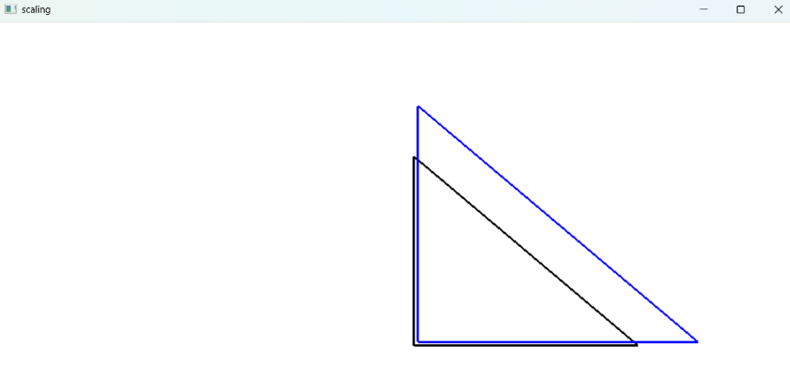
void scaling(){
glClear(GL_COLOR_BUFFER_BIT);
glLineWidth(3);
or_triangle();
glColor3f(0.0, 0.0, 1.0);
glBegin(GL_LINES);
glVertex2i(x1*sx,Y_1*sy);
glVertex2i(x2*sx,y2*sy);
glVertex2i(x2*sx,y2*sy);
glVertex2i(x3*sx,y3*sy);
glVertex2i(x3*sx,y3*sy);
glVertex2i(x1*sx,Y_1*sy);
glEnd();
glFlush();
}

void rotation(){
glClear(GL_COLOR_BUFFER_BIT);
glLineWidth(3);
or_triangle();
float rad = angle * 3.1416 / 180.0;

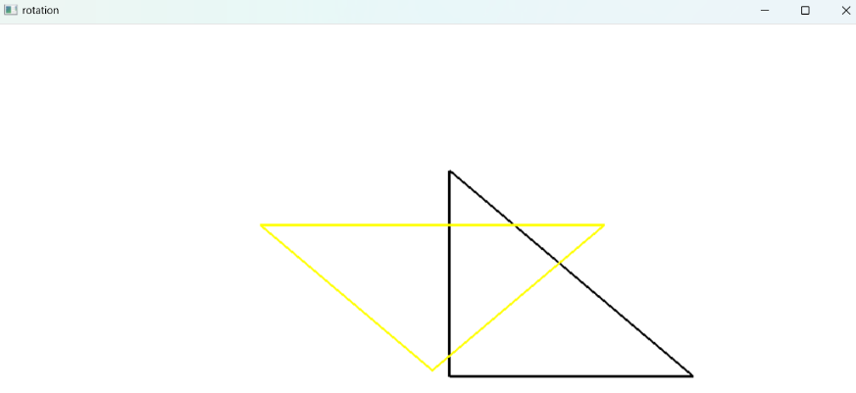
float rx1 = x1*cos(rad) - Y_1*sin(rad);
float rY_1 = x1*sin(rad) + Y_1*cos(rad);
float rx2 = x2*cos(rad) - y2*sin(rad);
float ry2 = x2*sin(rad) + y2*cos(rad);
float rx3 = x3*cos(rad) - y3*sin(rad);
float ry3 = x3*sin(rad) + y3*cos(rad);

glColor3f(1.0, 1.0, 0.0);
glBegin(GL_LINES);
glVertex2f(rx1,rY_1);
glVertex2f(rx2,ry2);
glVertex2f(rx2,ry2);
glVertex2f(rx3,ry3);
glVertex2f(rx3,ry3);
glVertex2f(rx1,rY_1);
glEnd();
glFlush();
}

void shearing(){
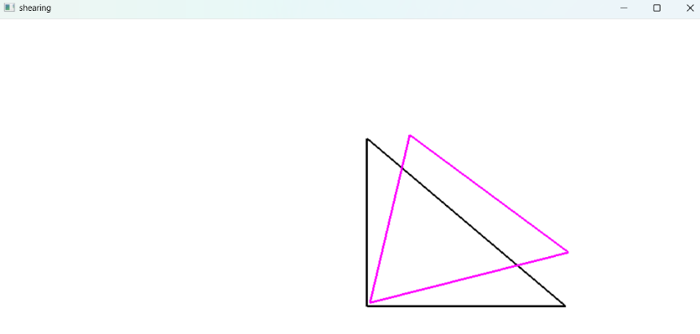
glClear(GL_COLOR_BUFFER_BIT);
glLineWidth(3);
or_triangle();
float shx1 = x1 + shx*Y_1;
float shY_1 = Y_1 + shy*x1;
float shx2 = x2 + shx*y2;
float shy2 = y2 + shy*x2;
float shx3 = x3 + shx*y3;
float shy3 = y3 + shy*x3;

glColor3f(1.0, 0.0, 1.0);
glBegin(GL_LINES);
glVertex2f(shx1,shY_1);
glVertex2f(shx2,shy2);
glVertex2f(shx2,shy2);
glVertex2f(shx3,shy3);
glVertex2f(shx3,shy3);
glVertex2f(shx1,shY_1);
glEnd();
glFlush();
}

void reflection(){
glClear(GL_COLOR_BUFFER_BIT);
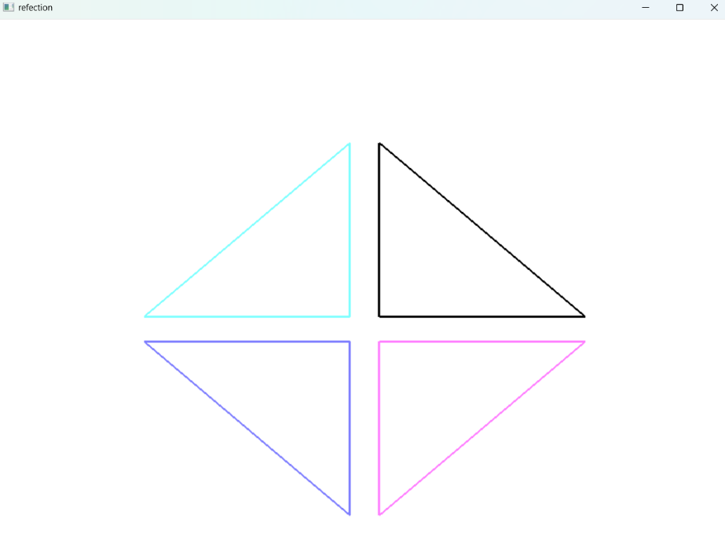
glLineWidth(3);
or_triangle();

if(x_axis){
float refx1=x1, refY_1=Y_1;
float refx2=x2, refy2=y2;
float refx3=x3, refy3=y3;
refY_1 = -Y_1;
refy2 = -y2;
refy3 = -y3;
glColor3f(1.0, 0.5, 1.0);
glBegin(GL_LINES);
glVertex2f(refx1,refY_1);
glVertex2f(refx2,refy2);
glVertex2f(refx2,refy2);
glVertex2f(refx3,refy3);
glVertex2f(refx3,refy3);
glVertex2f(refx1,refY_1);
glEnd();
}if(y_axis){
float refx1=x1, refY_1=Y_1;
float refx2=x2, refy2=y2;
float refx3=x3, refy3=y3;
refx1 = -x1;
refx2 = -x2;
refx3 = -x3;
glColor3f(0.5, 1.0, 1.0);
glBegin(GL_LINES);
glVertex2f(refx1,refY_1);
glVertex2f(refx2,refy2);
glVertex2f(refx2,refy2);
glVertex2f(refx3,refy3);
glVertex2f(refx3,refy3);
glVertex2f(refx1,refY_1);
glEnd();
}if(origin){
float refx1=x1, refY_1=Y_1;
float refx2=x2, refy2=y2;
float refx3=x3, refy3=y3;
refx1 = -x1; refY_1 = -Y_1;
refx2 = -x2; refy2 = -y2;
refx3 = -x3; refy3 = -y3;
glColor3f(0.5, 0.5, 1.0);
glBegin(GL_LINES);
glVertex2f(refx1,refY_1);
glVertex2f(refx2,refy2);
glVertex2f(refx2,refy2);
glVertex2f(refx3,refy3);
glVertex2f(refx3,refy3);
glVertex2f(refx1,refY_1);
glEnd();
}

glFlush();
}

void init()
{
glClearColor(1,1,1,1);
glMatrixMode(GL_PROJECTION);
gluOrtho2D(-500,500,-500,500);
}

int main(int argc, char *argv[])
{
cout << "Enter first point: ";
cin >> x1 >> Y_1;
cout << "Enter second point: ";
cin >> x2 >> y2;
cout << "Enter third point: ";
cin >> x3 >> y3;
cout << "Enter translation factor: ";
cin >> tx >> ty;
cout << "Enter scaling factor: ";
cin >> sx >> sy;
cout << "Enter rotation angle (degree): ";
cin >> angle;
cout << "Enter shearing factors (shx shy): ";
cin >> shx >> shy;
cout << "reflection factor (x_axis,y_axis,origin)--(1 1 1):";
cin >> x_axis >> y_axis >> origin;

glutInit(&argc, argv);
glutInitWindowSize(1000,1000);
glutInitWindowPosition(0,0);
glutInitDisplayMode(GLUT_RGB | GLUT_SINGLE);

glutCreateWindow("translation");
init();
glutDisplayFunc(translation);

glutCreateWindow("scaling");
init();
glutDisplayFunc(scaling);

glutCreateWindow("rotation");
init();
glutDisplayFunc(rotation);

glutCreateWindow("shearing");
init();
glutDisplayFunc(shearing);

glutCreateWindow("refection");
init();
glutDisplayFunc(reflection);

glutMainLoop();

return 0;
}

